Water Conservation Academic Instruction and Research

The Problem
Municipal water demand is projected to increase significantly over the next fifty years. The Texas Water Development Board (TWDB) defines municipal use a use (Sales) to single family, commercial, multi-family, institutional and agricultural (primary plant sales) uses (Figure 1.). As this shows, municipal use must receive serious attention in the future.
Figure 1. Projected Texas Water Use
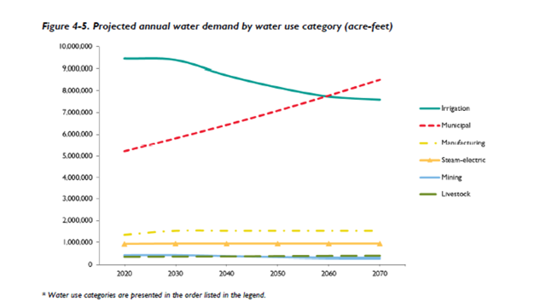
Figure 2. shows how water is used in municipal settings. Utilities also sell an additional 13 percent of its water to industrial users. This industrial use provides nearly a quarter of all manufacturing and electric power needs and is, therefore, part of many municipal water conservation programs.

Courses and Research at Texas Universities
Unfortunately, there are little or no efforts in Texas colleges and universities beyond landscape irrigation and design. Only Texas State University has an actual program of urban water conservation. Some Texas institutions have had some research done in the municipal water efficiency area and the use of alternate on-site sources, but apart from Texas State, do not have a dedicated course curriculum to train the many disciplines in this area. With respect to commercial and institutional water conservation, understanding how commercial type equipment ranging from food service equipment, medical and laboratory equipment, cooling towers and boilers to mention a few works and what are the energy and water efficiencies possible. The many commercial and institutional opportunities for on-site reuse and capture is another area needing attention. Much more is needed to ensure Texas has a cadre of people that understand the many facets, technologies, data analytics, and programmatic aspects. This also applies to the new field of on-site sources of water. This applies to the training of :
- Urban and regional planners,
- Engineering,
- Environmental studies, and
- Other areas where it may be applicable.
Energy Courses and Research at Texas Institutions of Higher Learning.
By contrast, many Texas institutions of higher education offer PhD level courses on energy demand management and alternate on-site energy sources. For example, the Webber Energy Group is a research group of professionals and students within the Cockrell School of Engineering at the University of Texas at Austin.
Texas A & M also offers many detailed energy demand management courses and both universities do significant research in these areas,
What is Needed?
Both direction and funding is needed to establish permanent programs at Texas institutions of higher learning. First, the Texas legislature should strongly encourage academic courses and research in the area. This includes:
- A set of coursework to train those working in the above-mentioned disciplines to even include degrees specifically in the areas of demand management and alternate on-site water sources;
- Course work concerning water efficiency in commercial and institutional facilities including the interaction of water and energy use,
- Study of the interaction and energy-water nexus of the end user (commercial equipment energy and water use),
- Coursework concerning the implementation and execution of effective water efficiency programs at the municipal level,
- Research on the statistical studies of all aspects of water efficiency and demand management,
- Development of statistical methods to predict seasonal water demand,
- Benchmarking commercial and institutional facility water use, and
- Engineering research on the availability, treatment and application of alternate sources of water to mention a few.
The Cost
The cost to fund one professor along with a graduate student stipend is in the range of $250,000 a year. If engineer research is involved, the cost can easily be over $500,000 a year. Providing funding for universities will cost from $2.5 to $5 million dollars a year. With this level of funding, some five to eight universities could begin these programs
Proposed Water Conservation Advisory Council Action
The council, in conjunction with the Texas Water Development Board, and the Texas Section of the American Water Works Association will form an advisory group academic advisors will work to develop specific recommendations for the next Legislative session concerning the following:
- An analysis if the current state of academic activity in this area, or the lack thereof;
- A more detailed analysis of the type of courses and research needed;
- Which State supported universities and institutional of higher learning would be targeted for funding;
- How the fund would be administered; and
- An estimate of the cost to support this legislation.
The council will also form a group to have oversight of what is funded.

